W03 Learning Activities: CSS Variables
Overview
CSS variables are a powerful tool for managing a website's design. They allow you to create reusable values that can be used throughout a stylesheet, helping to maintain design congruency. This activity will introduce you to CSS variables and how to use them in your projects.
Websites at professional companies are often very large and complex and use the same colors or values in many places throughout the CSS. If these values need to change in the future, it can be difficult to find and change them all consistently. By creating a custom CSS variable, you can define the value in one place and then use it throughout the rest of the CSS, making it easier to keep everything consistent and make changes when needed.
Prepare
CSS variables are defined using two dashes followed by a name, like --main-color. You can store colors, sizes, fonts, or any CSS value in a variable. To use the variable, you write var() with the variable name inside the parentheses.
Variables are usually defined in the :root selector, which makes them available to use anywhere in your CSS file. The :root selector represents the top level of your document.
Defining CSS Variables
To create a CSS variable, you define it inside a CSS rule using the double-dash syntax. The most common practice is to define all your variables at the top of your CSS file inside the :root selector.
- Variable names must start with two dashes (--)
- Variable names are case-sensitive
- Variable values can be any valid CSS value
- Global variables are defined in :root
The following example shows four variables defined in the root. The first two store color values, and the last two store size measurements that can be used for fonts and spacing.
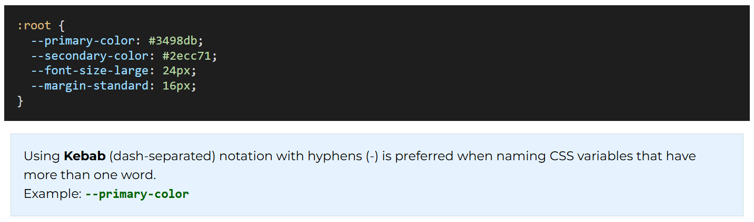
Using CSS Variables
Once you have defined variables, you can use them anywhere in your CSS by calling the var() function. Inside the parentheses, write the variable name exactly as you defined it, including the two dashes.
- var() function retrieves the value of a CSS variable
- Fallback values can be provided in case the variable is not defined
- Variables can be used for any CSS property value
In the following example, the header and button classes use the variables we defined earlier. Notice how the button uses var(--text-color, white) – this means if the --text-color variable is not defined, it will use white as the fallback value.
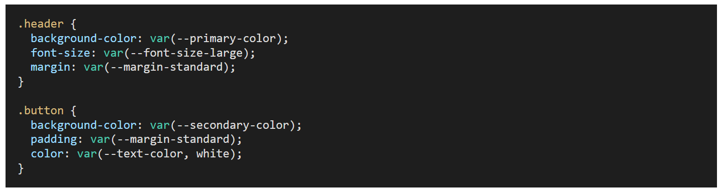
Benefits of Using CSS Variables
CSS variables provide several advantages that make your code more organized and easier to work with. They help create consistency across your website and make changes much simpler to implement.
- Easier maintenance – change one value to update it everywhere
- Consistency – ensures the same values are used throughout your design
- Readable code – meaningful names make CSS easier to understand
- Dynamic updates – variables can be changed with JavaScript
Example
The following examples shows how CSS variables can be defined and used.
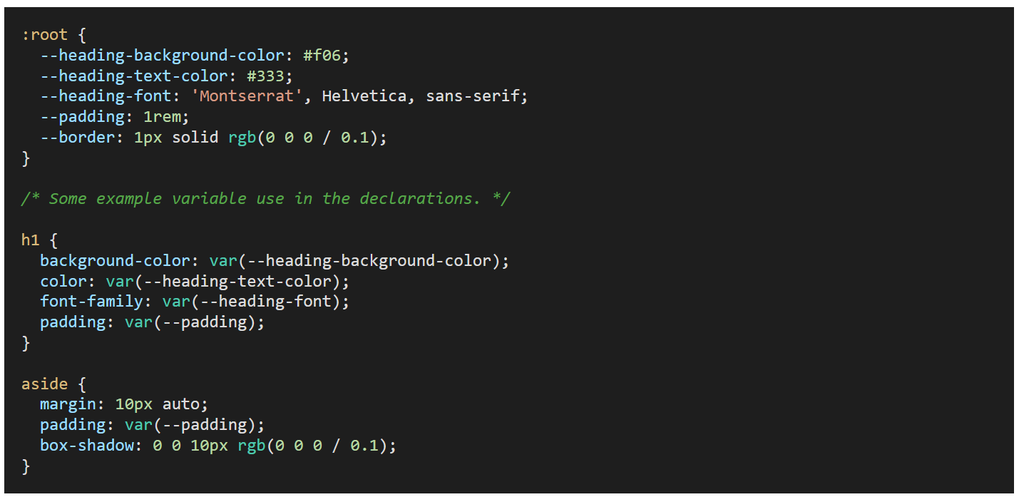
Activity Instructions
- In your main wdd130 site, open up your existing styles.css file.
- Create a :root {} rule at the top of the file.
- Review your course home page CSS and look for colors, fonts, sizes, and other values that are repeated.
- Replace those repeated CSS property values with CSS variables.
- Test your page in your local browser using Live Server or Five Server.
- Commit and sync/push your work to your wdd130 GitHub Pages enabled repository.
- Share your work with others on Microsoft Teams in Week 03 Forum

